Gwinnett County Public Schools Mathematics: Second Grade – Instructional Calendar 2013-2014
Standards for Mathematical Practice #s 1- 8 taught throughout all units.
1st Quarter | 2nd Quarter | 3rd Quarter | 4th Quarter
GCPS Unit 1 (GA Unit 1) | GCPS Unit 2 (GA Unit 2) | GCPS Unit 3 (GA Unit 3) | GCPS Unit 4 (GA Unit 4) | GCPS Unit 5 (GA Unit 5) | GCPS Unit 6 (GA Unit 6)
Base Ten | Add. and Sub. | Measurement | Applying Base Ten | Geometry | Multiplication
7.NBT.1 explain that the three digits of a three-digit number represent amounts of hundreds, tens, and ones (e.g., 706 equals 7 hundreds, 0 tens, and 6 ones)  8.NBT.1_a. explain that 100 can be thought of as a bundle of ten tens, called a "hundred"  9.NBT.1_b. explain the numbers 100, 200, 300, 400, 500, 600, 700, 800, 900 refer to one, two, three, four, five, six, seven, eight, or nine hundreds (and 0 tens and 0 ones)  10.NBT.2 count within 1000; skip-count by 5s, 10s, and 100s  11.NBT.3 read, write, and represent numbers to 1000 using a variety of models, diagrams and base ten numerals including standard and expanded form  12.NBT.4  compare two three-digit numbers based on meanings of the hundreds, tens, and ones digits, using >,=,and< symbols to record the results of comparisons  27.MD.10 draw a picture graph and a bar graph (with single-unit scale) to represent a data set with up to four categories. Solve simple put-together, take-apart, and compare problems using information presented in a bar graph * | 1.OA.1 use addition and subtraction within 100 to solve one- and two-step word problems involving situations of adding to, taking from, putting together, taking apart, and comparing with unknowns in all positions. (e.g., by using drawings and equations with a symbol for the unknown number to represent the problem)**  2.OA.2 fluently add and subtract within 20 using mental strategies. By the end of Grade 2, know from memory all sums of two one-digit numbers  13.NBT.5 add and subtract fluently within 100 using strategies based on place value, properties of operations, and/or the relationship between addition and subtraction  27.MD.10 draw a picture graph and a bar graph (with single-unit scale) to represent a data set with up to four categories. Solve simple put-together, take-apart, and compare problems using information presented in a bar graph * | 18.MD.1 measure length by determining, selecting and using an appropriate tool (rulers, yardsticks, meter sticks, measuring tapes) and unit (in., ft., yd., cm, m)  19.MD.2 compare and explain the relationship of inches, feet, yards, centimeters and meters by measuring an object twice using different units  20.MD.3 estimate lengths using units of inches, feet, yards, centimeters and meters, then measure to determine if estimations were reasonable  21.MD.4 measure to determine how much longer one object is than another, expressing the length difference in terms of a standard length unit (relate addition and subtraction to length)  22.MD.5 use addition and subtraction within 100 to solve word problems involving lengths that are given in the same units, e.g., by using drawings (such as drawings of rulers) and equations with a symbol for the unknown number in the problem  23.MD.6 represent whole numbers as lengths from 0 on a number line with equally spaced points corresponding to the numbers 0, 1, 2, ..., and represent whole-number sums and differences within 100 on a number line diagram  24.MD.7 use analog and digital clocks to tell and write time to the nearest five minutes using AM and PM  26.MD.9 generate measurement data by measuring lengths of several objects to the nearest whole unit, or by making repeated measurements of the same object. Show the measurements by making a line plot, where the horizontal scale is marked off in whole-number units  27.MD.10 draw a picture graph and a bar graph (with single-unit scale) to represent a data set with up to four categories. Solve simple put-together, take-apart, and compare problems using information presented in a bar graph * | 14.NBT.6 add up to four two-digit numbers using strategies based on place value and properties of operations  15.NBT.7 add and subtract within 1000, using concrete models or drawings and strategies based on place value, properties of operations, and/or the relationship between addition and subtraction; relate the strategy to a written method. Understand that in adding or subtracting three-digit numbers, one adds or subtracts hundreds and hundreds, tens and tens, ones and ones; and sometimes it is necessary to compose or decompose tens or hundreds  16.NBT.8 use mental math strategies to add and subtract 10 or 100 to a given number between 100-900  17.NBT.9 explain why addition and subtraction strategies work using place value and the properties of operations  25.MD.8 solve word problems involving dollar bills, quarters, dimes, nickels, and pennies, using $ and ¢ symbols appropriately (e.g., if you have 2 dimes and 3 pennies, how many cents do you have?)  27.MD.10 draw a picture graph and a bar graph (with single-unit scale) to represent a data set with up to four categories. Solve simple put-together, take-apart, and compare problems using information presented in a bar graph * | 29.G.1 recognize and draw shapes having specified attributes, such as a given number of angles or a given number of equal faces and identify triangles, quadrilaterals, pentagons, hexagons, and cubes. Sizes are compared directly or visually, not compared by measuring.  30.G.2 partition a rectangle into rows and columns of same-size squares and count to find the total number of them  31.G.3 partition circles and rectangles into two, three, or four equal shares, describe the shares using the words halves, thirds, half of, a third of, etc., and describe the whole as two halves, three thirds, four fourths. Recognize that equal shares of identical wholes need not have the same shape  27.MD.10 draw a picture graph and a bar graph (with single-unit scale) to represent a data set with up to four categories. Solve simple put-together, take-apart, and compare problems using information presented in a bar graph * | 4.OA.3  determine whether a group of objects (up to 20) has an odd or even number of members. e.g., by pairing objects or counting them by 2s; write an equation to express an even number as a sum of two equal addends  6.OA.4 apply the use of repeated addition (skip counting), model arrays up to 5 rows and 5 columns to determine a total number of objects, and write an equation to express the total as a sum of equal addends  27.MD.10 draw a picture graph and a bar graph (with single-unit scale) to represent a data set with up to four categories. Solve simple put-together, take-apart, and compare problems using information presented in a bar graph *  Unit 7: Preview—Base Ten
G—Geometry, MD—Measurement and Data, NBT—Number and Operations in Base Ten, OA—Operations and Algebraic Thinking; *MD.10 to be assessed in 4th Quarter, ** See Glossary, Table 1
Common Core Appendix: Table 1. Common addition and subtraction situations.
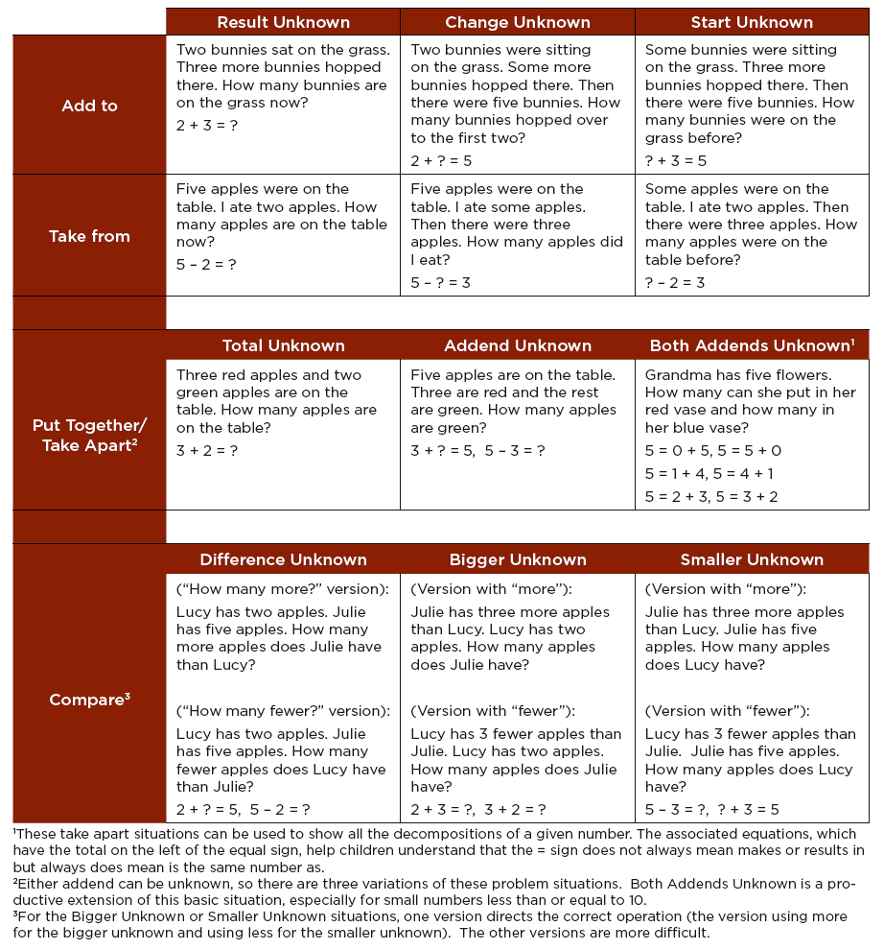
Standards for Mathematical Practice - Second Grade Specific

Mathematical Practices are listed with each grade’s mathematical content standards to reflect the need to connect the mathematical practices to mathematical content in instruction.
The Standards for Mathematical Practice describe varieties of expertise that mathematics educators at all levels should seek to develop in their students. These practices rest on important “processes and proficiencies” with longstanding importance in mathematics education. The first of these are the NCTM process standards of problem solving, reasoning and proof, communication, representation, and connections. The second are the strands of mathematical proficiency specified in the National Research Council’s report Adding It Up: adaptive reasoning, strategic competence, conceptual understanding (comprehension of mathematical concepts, operations and relations), procedural fluency (skill in carrying out procedures flexibly, accurately, efficiently and appropriately), and productive disposition (habitual inclination to see mathematics as sensible, useful, and worthwhile, coupled with a belief in diligence and one’s own efficacy).
Students are expected to:

1. Make sense of problems and persevere in solving them.
In second grade, students realize that doing mathematics involves solving problems and discussing how they solved them. Students explain to themselves the meaning of a problem and look for ways to solve it. They may use concrete objects or pictures to help them conceptualize and solve problems. They may check their thinking by asking themselves, “Does this make sense?” They make conjectures about the solution and plan out a problem-solving approach.

2. Reason abstractly and quantitatively.
Younger students recognize that a number represents a specific quantity. They connect the quantity to written symbols. Quantitative reasoning entails creating a representation of a problem while attending to the meanings of the quantities. Second graders begin to know and use different properties of operations and objects.

3. Construct viable arguments and critique the reasoning of others.
Second graders may construct arguments using concrete referents, such as objects, pictures, drawings, and actions. They practice their mathematical communication skills as they participate in mathematical discussions involving questions like “How did you get that?”, “Explain your thinking,” and “Why is that true?” They not only explain their own thinking, but listen to others’ explanations. They decide if the explanations make sense and ask appropriate questions.

4. Model with mathematics.
In early grades, students experiment with representing problem situations in multiple ways including numbers, words (mathematical language), drawing pictures, using objects, acting out, making a chart or list, creating equations, etc. Students need opportunities to connect the different representations and explain the connections. They should be able to use all of these representations as needed.

5. Use appropriate tools strategically.
In second grade, students consider the available tools (including estimation) when solving a mathematical problem and decide when certain tools might be better suited. For instance, second graders may decide to solve a problem by drawing a picture rather than writing an equation.

6. Attend to precision.
As young children begin to develop their mathematical communication skills, they try to use clear and precise language in their discussions with others and when they explain their own reasoning.

7. Look for and make use of structure.
Second graders look for patterns. For instance, they adopt mental math strategies based on patterns (making ten, fact families, doubles).

8. Look for and express regularity in repeated reasoning.
In the early grades, students notice repetitive actions in counting and computation, etc. When children have multiple opportunities to add and subtract “ten” and multiples of “ten” they notice the pattern and gain a better understanding of place value. Students continually check their work by asking themselves, “Does this make sense?”

