Gwinnett County Public Schools Mathematics: First Grade – Instructional Calendar 2013-2014
Standards for Mathematical Practice #s 1- 8 taught throughout all units.
1st Quarter |  | 2nd Quarter | 3rd Quarter | 4th Quarter
GCPS Unit 1 (GA Units 1, 2) | GCPS Unit 2 (GA Unit 3) | GCPS Unit 3 (GA Unit 4) | GCPS Unit 4 (GA Unit 5) | GCPS Unit 5 (GA Unit 6)
Base Ten Numbers | Shapes and Fractions | Sort, Comp., Order | Operations | Place Value
10. NBT.1 count to 120, starting at any number less than 120. In this range, read and write numerals and represent a number of objects with a written numeral  21. NBT.PRE exchange equivalent quantities of coins by making fair trades involving combinations of pennies, nickels, dimes, and quarters and count out a combination needed to purchase items less than a dollar (not assessed, different components can be taught throughout the year)  25. MD.4 organize, represent, and interpret data with up to three categories; ask and answer questions about the total number of data points, how many in each category, and how many more or less are in one category than in another * | 27.G.1 distinguish between defining attributes (e.g., triangles are closed and three-sided) versus non-defining attributes (e.g., color, orientation, overall size); build and draw shapes to possess defining attributes  28. G.2 compose two-dimensional shapes (rectangles, squares, trapezoids, triangles, half-circles, and quarter-circles) or three-dimensional shapes (cubes, right rectangular prisms, right circular cones, and right circular cylinders) to create a composite shape and to compose new shapes from the composite shape. Students do not need to learn formal names such as “right rectangular prism.”  29. G.3 partition circles and rectangles into two and four equal shares, describe the shares using the words halves, fourths, and quarters, and use the phrases half of, fourth of, and quarter of. Describe the whole as two of, or four of the shares. Understand for these examples that decomposing into more equal shares creates smaller shares  25. MD.4  organize, represent, and interpret data with up to three categories; ask and answer questions about the total number of data points, how many in each category, and how many more or less are in one category than in another * | 22.MD.1 order the length of three objects; compare the lengths of two objects by using direct comparison or a third object  23. MD.2 express the length of an object as a whole number of length units, by laying multiple copies of a shorter object (the length unit) end to end; understand that the length measurement of an object is the number of same-size length units that span it with no gaps or overlaps. Limit to contexts where the object being measured is spanned by a whole number of length units with no gaps or overlaps  24. MD.3 tell and write time to the nearest hour and half-hour using analog and digital clocks  25. MD.4 organize, represent, and interpret data with up to three categories; ask and answer questions about the total number of data points, how many in each category, and how many more or less are in one category than in another* | 1. OA.1 use addition and subtraction within 20 to solve word problems involving situations of adding to, taking from, putting together, taking apart, and comparing with unknowns in all positions (e.g., by using objects, drawings, and equations with a symbol for the unknown number to represent the problem)**  2. OA.2 solve word problems that call for addition of three whole numbers whose sum is less than or equal to 20 (e.g., by using objects, drawings, and equations with a symbol for the unknown number to represent the problem)  3. OA.3 explore and apply properties of operations as strategies to add and subtract (e.g., If 8 + 3 = 11 is known, then 3 + 8 = 11 is also known (Commutative property of addition). To add 2 + 6 + 4, the second two numbers can be added to make a ten, so 2 + 6 + 4 = 2 + 10 = 12 (Associative property of addition). Students do not use formal terms for these properties. Problems should be within 20.  4. OA.4 model and explain subtraction as an unknown-addend problem (e.g., subtract 10 - 8 by finding the number that makes 10 when added to 8)  5. OA.5 relate counting to addition and subtraction (e.g., by counting on 2 to add 2)  6. OA.6 add and subtract within 20, demonstrating fluency for addition and subtraction within 10. Use strategies such as counting on; making ten (e.g., 8 + 6 = 8 + 2 + 4 = 10 + 4 = 14); decomposing a number leading to a ten (e.g., 13 - 4 = 13 - 3 - 1 = 10 - 1 = 9); using the relationship between addition and subtraction (e.g., adding 6 + 7 by creating the known equivalent 6 + 6 + 1 = 12 + 1 = 13).  7. OA.7 model and explain the meaning of the equal sign, and determine if equations involving addition and subtraction are true or false. (e.g., which of the following equations are true and which are false? 6 = 6, 7 = 8 - 1, 5 + 2 = 2 + 5, 4 + 1 = 5 + 2)  9. OA.8 determine the unknown whole number in an addition or subtraction equation relating to three whole numbers by using symbols (e.g., determine the unknown number that makes the equation true in each of the equations 8 + ? = 11; 5 = □ - 3; 6 + 6 = ∆)  25. MD.4  organize, represent, and interpret data with up to three categories; ask and answer questions about the total number of data points, how many in each category, and how many more or less are in one category than in another * | 12. NBT.2 model and explain that a two-digit number represents amounts of tens and ones  13. NBT.2_a. explain that 10 can be thought of as a bundle of ten ones called a "ten"  14. NBT.2_b. model the numbers 11 to 19 showing they are composed of a ten and one, two, three, four, five, six, seven, eight, or nine ones  15. NBT.2_c. explain that the numbers 10, 20, 30, 40, 50, 60, 70, 80, and 90 refer to one, two, three, four, five, six, seven, eight, or nine tens and 0 ones  16. NBT.3 compare two two-digit numbers based on meanings of the tens and ones digits, recording the results of comparisons with the symbols >, =, and <  17. NBT.4 add within 100, including adding a two-digit number and a one-digit number, and adding a two-digit number and a multiple of 10, using concrete models or drawings and strategies based on place value, properties of operations, and/or the relationship between addition and subtraction; relate the strategy to a written method and explain the reasoning used. Understand that in adding two-digit numbers, one adds tens and tens, ones and ones; and sometimes it is necessary to compose a ten  19. NBT.5 using mental math strategies identify one more than, one less than, 10 more than, or 10 less than a given two-digit number explaining strategy used  20. NBT.6 subtract multiples of 10 in the range 10 - 90 from multiples of 10 in the range 10 - 90 (positive or zero differences), using concrete models or drawings and strategies based on place value, properties of operations, and/or the relationship between addition and subtraction; relate the strategy to a written method and explain the reasoning used  25. MD.4  organize, represent, and interpret data with up to three categories; ask and answer questions about the total number of data points, how many in each category, and how many more or less are in one category than in another *  Unit 6: Preview—Base Ten
G—Geometry, MD—Measurement and Data, NBT—Number and Operations in Base Ten, OA—Operations and Algebraic Thinking; * MD.4 will be assessed in 4th Quarter, ** See Glossary, Table 1
Common Core Appendix: Table 1. Common addition and subtraction situations.
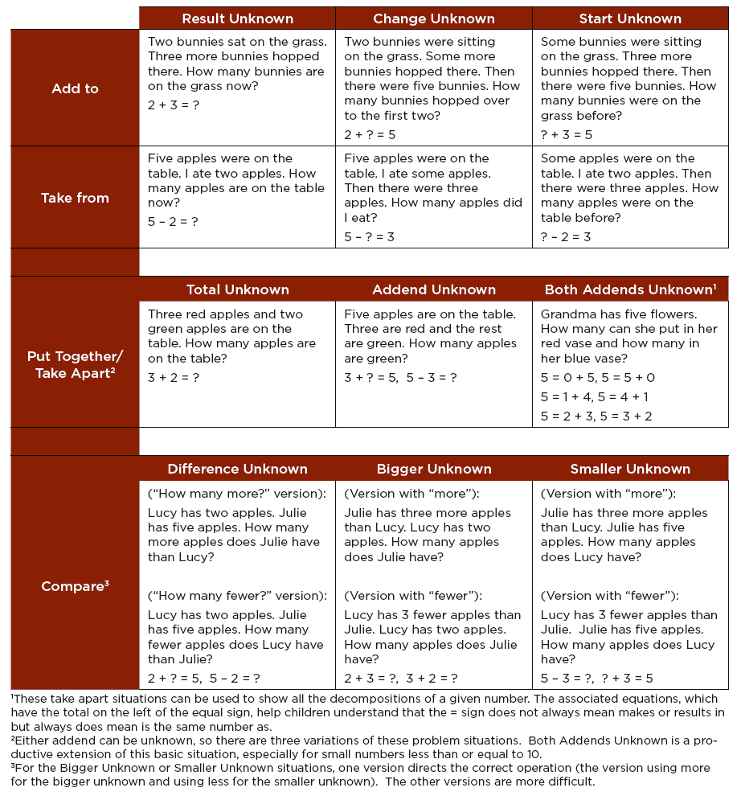
Standards for Mathematical Practice - First Grade Specific

Mathematical Practices are listed with each grade’s mathematical content standards to reflect the need to connect the mathematical practices to mathematical content in instruction.
The Standards for Mathematical Practice describe varieties of expertise that mathematics educators at all levels should seek to develop in their students. These practices rest on important “processes and proficiencies” with longstanding importance in mathematics education. The first of these are the NCTM process standards of problem solving, reasoning and proof, communication, representation, and connections. The second are the strands of mathematical proficiency specified in the National Research Council’s report Adding It Up: adaptive reasoning, strategic competence, conceptual understanding (comprehension of mathematical concepts, operations and relations), procedural fluency (skill in carrying out procedures flexibly, accurately, efficiently and appropriately), and productive disposition (habitual inclination to see mathematics as sensible, useful, and worthwhile, coupled with a belief in diligence and one’s own efficacy). Students are expected to:

1. Make sense of problems and persevere in solving them.
In first grade, students realize that doing mathematics involves solving problems and discussing how they solved them. Students explain to themselves the meaning of a problem and look for ways to solve it. Younger students may use concrete objects or pictures to help them conceptualize and solve problems. They may check their thinking by asking themselves, “Does this make sense?” They are willing to try other approaches.

2. Reason abstractly and quantitatively.
Younger students recognize that a number represents a specific quantity. They connect the quantity to written symbols. Quantitative reasoning entails creating a representation of a problem while attending to the meanings of the quantities.

3. Construct viable arguments and critique the reasoning of others.
First graders construct arguments using concrete referents, such as objects, pictures, drawings, and actions. They also practice their mathematical communication skills as they participate in mathematical discussions involving questions like “How did you get that?” “Explain your thinking,” and “Why is that true?” They not only explain their own thinking, but listen to others’ explanations. They decide if the explanations make sense and ask questions.

4. Model with mathematics.
In early grades, students experiment with representing problem situations in multiple ways including numbers, words (mathematical language), drawing pictures, using objects, acting out, making a chart or list, creating equations, etc. Students need opportunities to connect the different representations and explain the connections. They should be able to use all of these representations as needed.

5. Use appropriate tools strategically.
In first grade, students begin to consider the available tools (including estimation) when solving a mathematical problem and decide when certain tools might be helpful. For instance, first graders decide it might be best to use colored chips to model an addition problem.

6. Attend to precision.
As young children begin to develop their mathematical communication skills, they try to use clear and precise language in their discussions with others and when they explain their own reasoning.

7. Look for and make use of structure.
First graders begin to discern a pattern or structure. For instance, if students recognize 12 + 3 = 15, then they also know 3 + 12 = 15. (Commutative property of addition.) To add 4 + 6 + 4, the first two numbers can be added to make a ten, so 4 + 6 + 4 = 10 + 4 = 14.

8. Look for and express regularity in repeated reasoning.
In the early grades, students notice repetitive actions in counting and computation, etc. When children have multiple opportunities to add and subtract “ten” and multiples of “ten” they notice the pattern and gain a better understanding of place value. Students continually check their work by asking themselves, “Does this make sense?”

